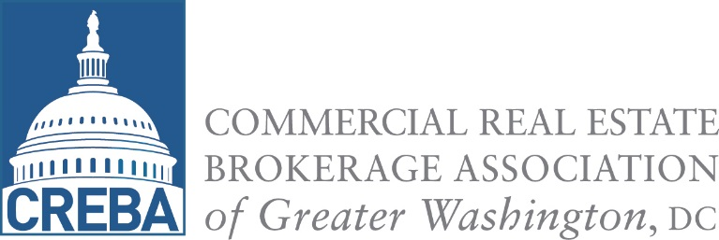

8400 Westpark Drive
Phone: 703.454.0856
Fax: 703.995.4632
www.creba.org
For Immediate Release
April 21, 2015
Contact: Denise Jackson
703.610.0259
djackson@creba.org

Media Advisory

WHO: The Commercial Real Estate Brokerage Association of Greater Washington, DC (CREBA)

WHAT: 2015 Annual Awards Dinner.

WHEN: Wednesday, April 15.

WHERE: The Fairmont Hotel, 2401 M Street, NW, Washington, DC

CREBA Announces 2015 Award Winners
The Commercial Real Estate Brokerage Association of Greater Washington D.C. (CREBA) named its top agents in finance, development, sales, and leasing for 2014 at the 2015 Annual Awards Dinner on Wednesday, April 15 at the Fairmont Hotel in Washington, DC. The prestigious Brendan McCarthy Memorial Award was presented to Bruce Pascal of Vornado Charles E. Smith. Eric West of West Lane & Schlager was recipient of the Broker of the Year award, which this year was renamed the James L. Eichberg Award, in memory of the late and revered Jim Eichberg, community legacy and co-founder of Smithy Braeden Co. Jenna Polivka of DTZ received the Rising Star Award for superior production and association involvement for members 35-years and younger.
The Dinner was attended by over 420 commercial real estate professionals and is the only awards event of its kind that recognizes top individual production in leasing, sales and finance for the commercial real estate industry.

Complete List of 2015 CREBA Award Winners

Brendan McCarthy Memorial Award: Bruce Pascal, Vornado Charles E. Smith

James L. Eichberg Broker of the Year Award: Eric West, West Lane & Schlager, LLC

Rising Star Award: Jenna Polivka, DTZ

Best in the Industry:

Architecture Firm: KGD Architecture
Contractor: Davis Construction
Developer: Hines
Furniture Vendor: Washington Workplace
Landlord: Paramount Group, Inc.
Law Firm: Greenstein DeLorme & Luchs, P.C.
Moving Company: Fitzgerald Movers
Project of the Year: City Center DC - Hines
Project Management: DTZ

Sales / Financing Firm of the Year: DTZ

Leasing Firm of the Year: CBRE

Sales Agents of the Year
- DC: Paul Collins/William Collins, DTZ (Tie)
- MD: William Kent, CBRE
- VA: Drew Flood/James Cassidy/Jud Ryan, DTZ (Tie)
- Regional: Paul Collins/William Collins, DTZ (Tie)

Leasing Agents of the Year
- DC: Randy Harrell, CBRE
- MD: Christopher Coccaro, JLL
- VA: Lou Christopher, CBRE
- Regional: Randy Harrell, CBRE

Developer/Landlord Agent of the Year
- J Quinn Rounsaville – The JBG Companies

Regional Finance Agent of the Year
- Regional: David Webb, CBRE

Top Regional GSA Leasing Agent:
- Marcy Owens Test – CBRE

Retail Agents of the Year
- David Dochter & Matt Alexander – Dochter & Alexander Retail Advisors (Tie)

Leasing Transactions of the Year
- DC: IFC at 2100 K by Steve Lustgarten and Owen Billman, Blake Real Estate; Craig Lussi, Tenant Consulting

- MD: CNSI at Research Office Center 1 by Christopher Coccaro, Pete Briskman, Mia Eglinton, Bella Schiro, JLL; Dave Millar, Brandywine

- VA: Corporate Executive Board Headquarters at Central Place by Lou Christopher, CBRE and Paul Adkins of The JBG Companies

Leasing Transactions of the Year under 75,000 RSF:
- Eastern Foundry at 2011 Crystal Place by Andy O’Brien, Stephen Burman, JLL; Randy Lennon, Jim Creedon, Vornado Charles E. Smith

Sales Transactions of the Year
- DC: 2401 Pennsylvania Avenue by William Collins, Paul Collins, Jud Ryan, Drew Flood, James Cassidy and Chris Doerr, DTZ

- VA: Patriots Park by William Collins, Paul Collins, Jud Ryan, Drew Flood, James Cassidy, DTZ

Finance Transactions of the Year
- DC: 601 New Jersey Ave by John Campanella, Phillip Mudd & Bradley Geiger DTZ

- MD: Quarry Springs Residential by David Webb and Jamie Butler, CBRE

- VA: Central Place Residential by David Webb, Jamie Butler CBRE

Retail Transaction of the Year
- H&M at 1133 Connecticut Ave by David Dochter & Matt Alexander, Dochter & Alexander Retail Advisors

###
CREBA is a regional trade association dedicated to serving commercial real estate interests throughout the District of Columbia, Suburban Maryland and Northern Virginia. Comprised of more than
500 commercial brokers and affiliated professionals, CREBA is a member-driven, customer-focused service organization, which exists to enhance our members' ability to serve the public, ethically, professionally and successfully.

